Manav Rachna International Institute of Research and Studies

School of Computer Applications

Department of Computer Applications

Submitted By
Student Name | KHUSHI SHARMA
Roll No | 24/SCA/BCA(AI/ML)/031
Program | BCA(AI&ML)
Subject | Python Programming
Semester | 3
Section/Group | C
Department | School of Computer Applications
Session / Batch | 2024-27
Submitted To
Faculty Name | Dr.Sakshi Gupta

Question 1: Write a Python program to calculate the number of days between two dates.
Sample dates: (2014, 7, 2), (2014, 7, 11).
Ans:

from datetime import date

date1 = date(2014, 7, 2) date2 = date(2014, 7, 11) delta = date2 - date1 print(f"The number of days between the two dates is: {delta.days}")

OUTPUT:

Question 2 : Write a Python program that accepts an integer (n) and computes the value of n+nn+nnn.
Ans:
n_str = input("Enter a number (n): ") n1 = int(n_str) n2 = int(n_str + n_str) n3 = int(n_str + n_str + n_str) result = n1 + n2 + n3
print(f"The result of {n1} + {n2} + {n3} is: {result}")
OUTPUT:
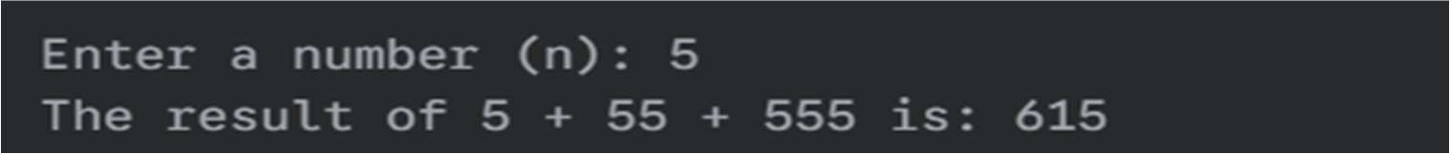
Question 3 : Write a Python program for accepting a number and depending on whether the number is even or odd, print out an appropriate message to the user.
ANS: try:
num = int(input("Enter a number: ")) if num % 2 == 0:
print(f"The number {num} is Even.") else:
print(f"The number {num} is Odd.") except ValueError:
print("Invalid input. Please enter an integer.")

OUTPUT:
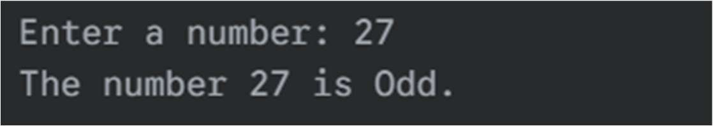

Question 4: Write a Python program which will find all such numbers which are divisible by 7 but are not a multiple of 5, between 2000 and 3200 (both included).
Ans:

result_list = [] for num in range(2000, 3201): if (num % 7 == 0) and (num % 5 != 0):
result_list.append(str(num))

print(",".join(result_list))
OUTPUT:

Question 5: Write a Python program to calculate the sum of three given numbers, if the values are equal then return thrice of their sum.
ANS:
def calculate_sum(a, b, c): if a == b == c:
return (a + b + c) * 3 else:
return a + b + c print(f"Sum of 1, 2, 3 is: {calculate_sum(1, 2, 3)}") print(f"Sum of 5, 5, 5 is: {calculate_sum(5, 5, 5)}")

OUTPUT:
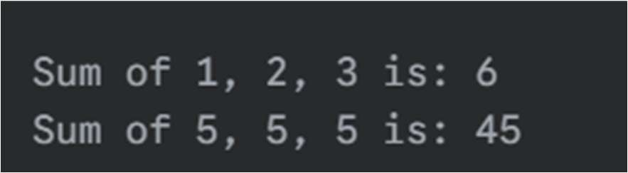

Question 6: Write a Python program to test whether a passed letter is a vowel or not.
ANS:
def check_vowel(letter):
vowels = "aeiou" if letter.lower() in vowels:
print(f"The letter '{letter}' is a Vowel.")
else:
print(f"The letter '{letter}' is a Consonant.")

check_vowel('a') check_vowel('B')

OUTPUT:
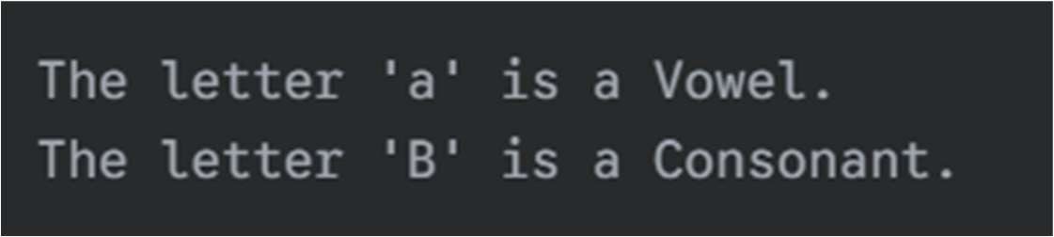

Question 7: Take a list, say for example this one: a = [1, 1, 2, 3, 5, 8, 13, 21, 34, 55, 89] and write the following program the following:
a) Instead of printing the elements one by one, make a new list that has all the elements less than 5 from this list in it and print out the new list. b) Write this in one line of Python.
c) Ask the user for a number and return a list that contains only elements from the original list that are smaller than that number given by the user.
ANS:
a = [1, 1, 2, 3, 5, 8, 13, 21, 34, 55, 89]

new_list = [] for item in a: if item < 5:
new_list.append(item) print(f"a) New list with elements less than 5: {new_list}") one_line_list = [item for item in a if item < 5] print(f"b) One-line version: {one_line_list}") try:
user_num = int(input("c) Enter a number: ")) user_list = [item for item in a if item < user_num] print (f" Elements smaller than {user_num}: {user_list}") except ValueError:
print ("Invalid input.")

OUTPUT:
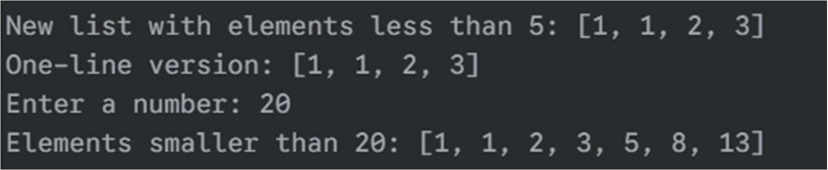
Question 8: Create a program that asks the user for a number and then prints out a list of all the divisors of that number.
ANS:

try:
num = int(input("Enter a number to find its divisors: ")) divisors = [i for i in range(1, num + 1) if num % i == 0] print(f"The divisors of {num} are: {divisors}") except ValueError:
print("Please enter a valid integer.")

OUTPUT:
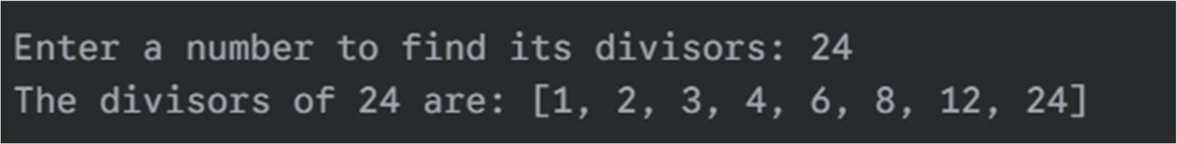

Question 9: Take two lists and write a program that returns a list that contains only the elements that are common between the lists (without duplicates).
ANS:
a = [1, 1, 2, 3, 5, 8, 13, 21, 34, 55, 89] b = [1, 2, 3, 4, 5, 6, 7, 8, 9, 10, 11, 12, 13]

common_elements = list(set(a) & set(b)) print(f"List a: {a}") print(f"List b: {b}")
print(f"Common elements: {common_elements}")

OUTPUT:
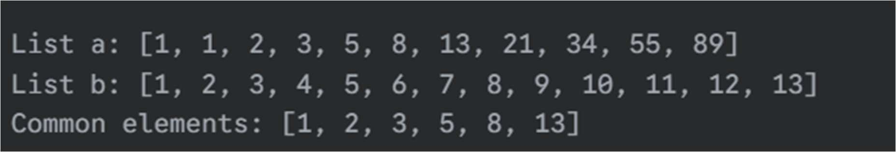

Question 10: Ask the user for a string and print out whether this string is a palindrome or not.
ANS:

text = input("Enter a string: ")
normalized_text = text.replace(" ", "").lower()

if normalized_text == normalized_text[::-1]:
print(f"'{text}' is a palindrome.") else:
print(f"'{text}' is not a palindrome.")

OUTPUT:
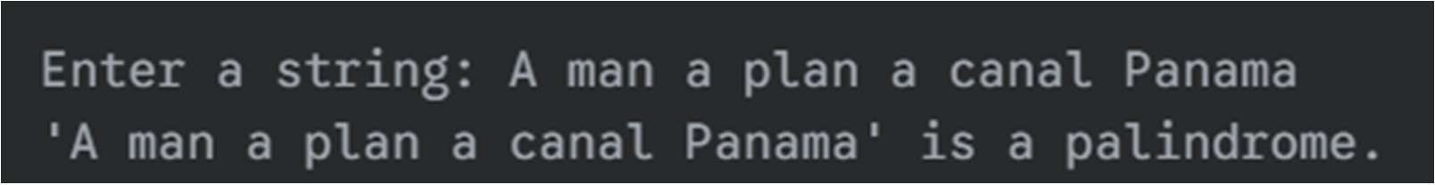

Question 11: Let’s say I give you a list saved in a variable: a = [1, 4, 9, 16, 25, 36, 49, 64, 81, 100]. Write one line of Python that takes this list a and makes a new list that has only the even elements of this list in it.
ANS:
a = [1, 4, 9, 16, 25, 36, 49, 64, 81, 100] even_list = [num for num in a if num % 2 == 0] print(f"Original list: {a}") print(f"List with only even numbers: {even_list}")

OUTPUT:
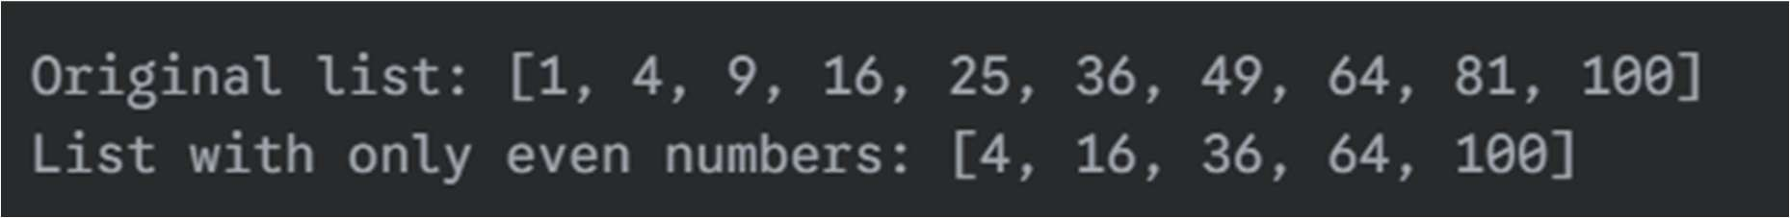

Question 12: Generate a random number between 1 and 9 (including 1 and 9). Ask the user to guess the number, then tell them whether they guessed too low, too high, or exactly right.
Ans:
import random

secret_number = random.randint(1, 9) guess = 0

print("I'm thinking of a number between 1 and 9.")

while guess != secret_number: try:
guess = int(input("Guess the number: ")) if guess < secret_number: print("Too low! Try again.") elif guess > secret_number: print("Too high! Try again.") else:
print("Exactly right! You guessed it!") except ValueError:
print("Invalid input. Please enter a number.")
OUTPUT:
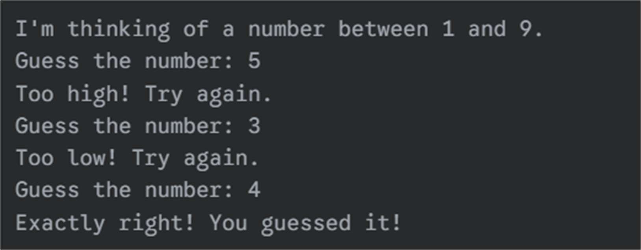
Q13: Ask the user for a number and determine whether the number is prime or not.
import math
def is_prime(n): if n <= 1:
return False if n <= 3:
return True if n % 2 == 0: return False i = 3 while i * i <= n: if n % i == 0: return False i += 2 return True
if __name__ == '__main__':
n = int(input('Enter a number: ')) if is_prime(n): print(f"{n} is a prime number") else: print(f"{n} is not a prime number") Input
17
Output
17 is a prime number

Q14. Write a program that takes a list and returns a new list that contains all the elements of the first list minus duplicates.
Program (q14_remove_duplicates.py)
def remove_duplicates(lst):
seen = set() result = [] for item in lst: if item not in seen: seen.add(item) result.append(item) return result
if __name__ == '__main__':
raw = input('Enter numbers separated by space: ').strip() lst = list(map(int, raw.split())) if raw else [] print('Result without duplicates:', remove_duplicates(lst)) Input
1 2 2 3 4 3 5 1
Output
Result without duplicates: [1, 2, 3, 4, 5]

Q15. Write a function that takes an ordered list of numbers (ascending) and another number. Decide whether the given number is inside the list and return/print a boolean.
def in_ordered_list(lst, num): lo, hi = 0, len(lst)-1 while lo <= hi: mid = (lo + hi) // 2 if lst[mid] == num: return True if lst[mid] < num: lo = mid + 1 else: hi = mid - 1 return False
if __name__ == '__main__':
raw = input('Enter ascending numbers separated by space: ').strip() lst = list(map(int, raw.split())) if raw else []
num = int(input('Enter number to search: ')) print(in_ordered_list(lst, num)) Input
1 3 5 7 9 11
5 Output
True

Q16. Implement a function that takes as input three variables and returns the largest of the three (without using built-in _{max()} function).
def largest_of_three(a, b, c):
largest = a if b > largest: largest = b if c > largest: largest = c return largest
if __name__ == '__main__':
a = int(input('Enter a: ')) b = int(input('Enter b: ')) c = int(input('Enter c: '))
print('Largest is', largest_of_three(a,b,c)) Input
3
7
5
Output
Largest is 7

Q17. Python program to perform read and write operations on a file.

path = input('Enter file path (will be created if not exists): ').strip()
# Read (if exists) and append a line. try: with open(path, 'r') as f: print('Current file contents:\n') print(f.read()) except FileNotFoundError: print('File not found — will create a new one.')
with open(path, 'a') as f:
line = input('Enter a line to append: ') + '\n'
f.write(line)
print('Done. New contents:') with open(path, 'r') as f: print(f.read())

Q18. Python program to copy the contents of a file to another file.
src = input('Enter source file path: ').strip() dst = input('Enter destination file path: ').strip() with open(src, 'r') as s, open(dst, 'w') as d: d.write(s.read()) print('Copy complete.')
Sample Run: Copy sample_file.txt to sample_copy.txt.

Q19. Python program to count frequency of characters in a given file.
Program (q19_char_freq.py)
from collections import Counter path = input('Enter file path: ').strip() with open(path,'r', encoding='utf-8') as f:
txt = f.read() freq = Counter(txt) for ch, cnt in freq.most_common(): print(repr(ch), cnt)

Q20. Python program to print each line of a file in reverse order (last line first).
path = input('Enter file path: ').strip() with open(path) as f: lines = f.readlines() for line in reversed(lines): print(line.rstrip('\n'))

Q21. Python program to compute the number of characters, words and lines in a file.
path = input('Enter file path: ').strip() with open(path) as f: content = f.read() lines = content.splitlines() num_chars = len(content) num_words = len(content.split()) num_lines = len(lines) print('Characters:', num_chars) print('Words:', num_words) print('Lines:', num_lines)

Q23. Write a program that accepts date of birth along with other personal details. Throw an exception if an invalid date is entered.
from datetime import datetime name = input('Enter name: ').strip()
dob_str = input('Enter DOB (YYYY-MM-DD): ').strip() try:
dob = datetime.strptime(dob_str, '%Y-%m-%d').date() except ValueError:
raise ValueError('Invalid date format. Expected YYYY-MM-DD') print(f'Name: {name}, DOB: {dob}')
Q24. Write a Regular Expression to represent all 10-digit mobile numbers. Rules: every number should contain exactly 10 digits. The first digit should be 7 or 8 or 9. Write a Python program to check whether the given number is valid.
import re
pattern = re.compile(r'^[789]\d{9}$')
num = input('Enter 10-digit mobile number: ').strip() if pattern.match(num):
print('Valid mobile number') else: print('Invalid mobile number')
Sample: 9123456789 -> Valid, 6123456789 -> Invalid.

Q25. A spell checker: program reads a file and displays all words that are not in a known-words list (common dictionary).
import re
# For practical file, include a small dictionary file or use an available wor d list.
dict_path = input('Enter dictionary file path (one word per line): ').strip() input_path = input('Enter file to check: ').strip() with open(dict_path) as d:
known = {w.strip().lower() for w in d if w.strip()} with open(input_path) as f: text = f.read().lower() words = re.findall(r"[a-z]+", text)
misspelled = sorted({w for w in words if w not in known}) if misspelled: print('Misspelled / unknown words:') for w in misspelled:
print(w) else: print('No unknown words found')

